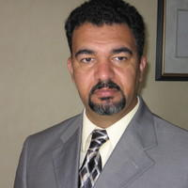

Dr. Abbas Kadhim is a senior fellow at the Foreign Policy Institute, SAIS, Johns Hopkins University and the President of the Institute of Shia Studies in Washington, D.C. His research interests focus on Iraq, Iran, Persian Gulf, and Islam. He earned a Ph.D. in Near Eastern Studies from the University of California, Berkeley in 2006. Between 2005 and 2013 Dr. Kadhim was an Assistant Professor of National Security Affairs/Middle East Studies at the Naval Postgraduate School in Monterey, California, and a Visiting Scholar at Stanford University. Prior to Joining SAIS, Dr. Kadhim held a Senior Government Affairs position at the Iraqi Embassy in Washington, DC. He is the author of Reclaiming Iraq: the 1920 Revolution and the Founding of the Modern State, University of Texas Press, 2012; and “The Hawza under Siege: A Study in the Ba’th Party Archives“, Boston University (2013).

