  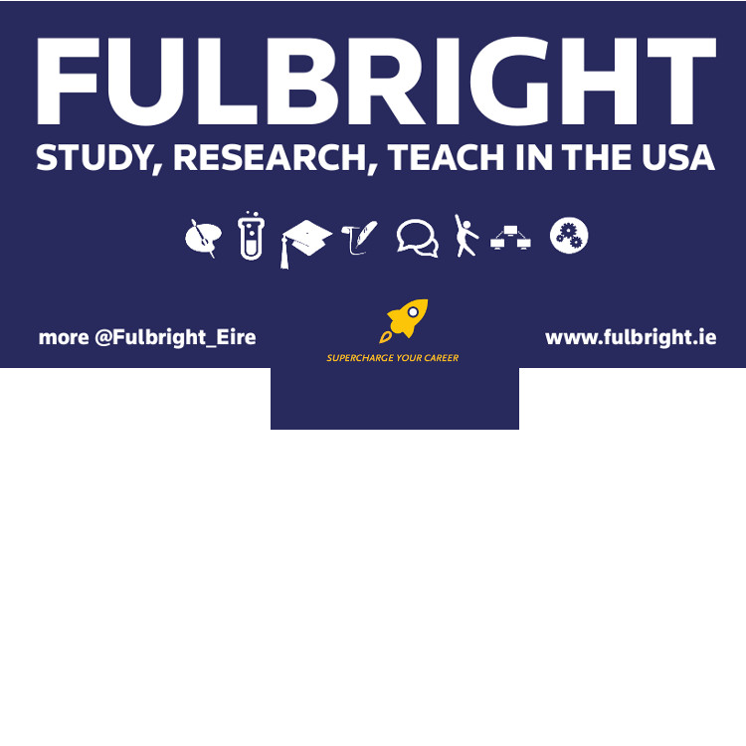
  The Fulbright Commission and Penn Law are offering this unique opportunity for an Irish student to travel to the U.S. to study for a general LL.M. at one of the leading universities in the U.S.
  Penn Law's program allows recipients to design their own curriculum, but students may choose to focus on a particular topic. Additionally, students will have the ability to participate in exceptional additional programs, including the Wharton Business and Law Certificate, the LL.M. Public Service Program, and Clinical Programs. The Fulbright Commission is seeking excellent applicants with strong leadership potential and a commitment to the ethos of being a Fulbrighter.
  AWARD APPLICATIONS OPEN: 28.08.2019
  AWARDS DEADLINE: 31.10.2019
  
  
  
  LAW
  cL
  STUDENT
  IRELAND→ U.S.
  LL.M. PROGRAM
  For Irish/E.U. Citizens
  fulbright commission
  54 Merrion Square
  Dublin 2
  D02 CX30
  IRELAND
  www.fulbright.ie
  @fulbright_eire

Fulbright Opportunity IN LAW

Eligibility
- Must be an Irish Citizen, or an E.U. citizen who has lived in the Republic of Ireland for 3+ years
- Must be a prospective postgraduate student with a minimum 2.1 undergraduate degree in Law and a clear course of study
- Leadership qualities and potential are essential, as well as a clear understanding of what it means to be a Fulbrighter
- Must not be a dual U.S.-Irish citizen, green card holder, or currently living in the U.S.
- Must not already have extensive experience of studying or living in the U.S.
How to Apply?
If you meet the above criteria, please visit www.fulbright.ie to review further information and FAQs. Then fill out this Fubright Inquiry Form.

We will then issue you the link to the online application system (known as Embark) and the guidelines
All applications are due by 4pm Thursday, 31 October 2019
You must also apply to and be accepted by Penn Law. Application instructions are available at www.law.upenn.edu/admissions/grad

FUNDING DETAILS
- A $30,000 grant from the University of Pennsylvania for its LL.M. program. You must be able to complete the entire length of the LLM. program. (Penn Law's grant is contingent on accepting the Fulbright)

- Monetary grant from the Fulbright Commission, plus accident and emergency insurance, cultural and professional programming, and J-1 visa administration from the Fulbright Program

ANYTHING ELSE YOU SHOULD KNOW?
- All successful applicants must comply with the two-year home rule, which means that awardees will not be eligible for U.S. residency or a visa until the two-year home rule in Ireland is complete.

- The successful candidate will be responsible for the remaining tuition and fees.

